**Laporan Tugas Kasir Restaurant Menggunakan PHP & MySQL**

Nama : Damarfana Rakhima Wahab

NIM : 18050623004

Prodi : D3 Manajemen Informatika

1. Transaksi

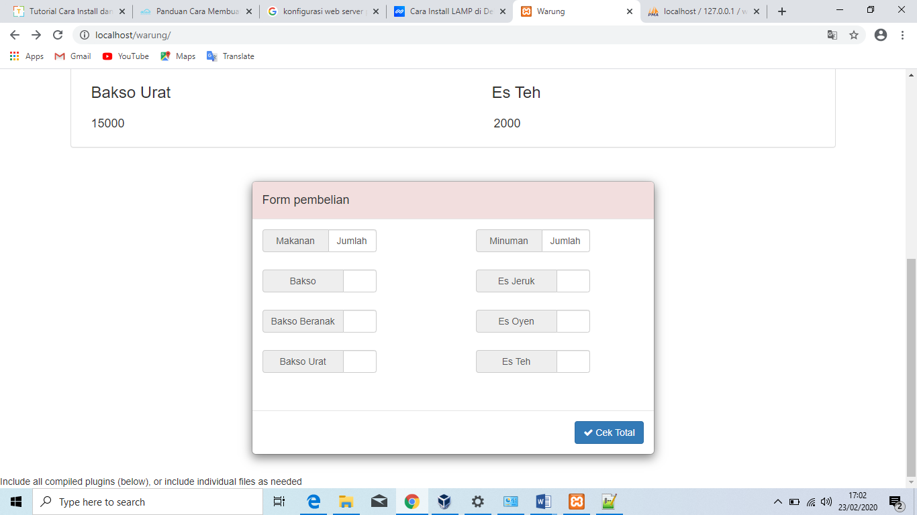

1. Menu

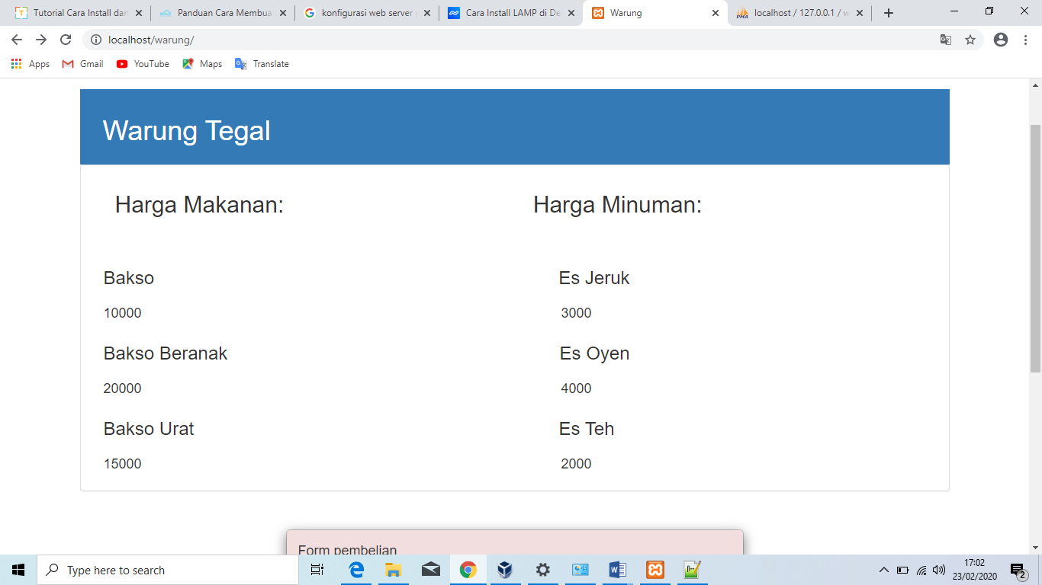

1. Struk

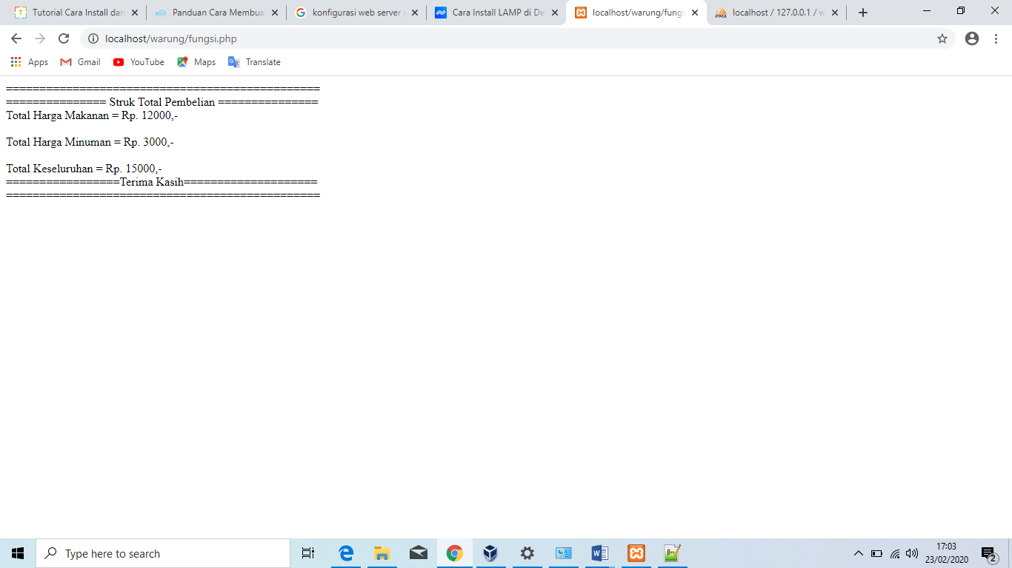

1. Class diagram

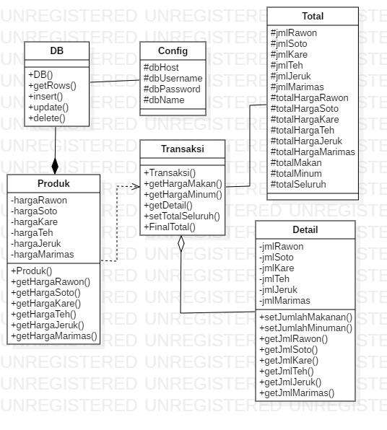

1. Database

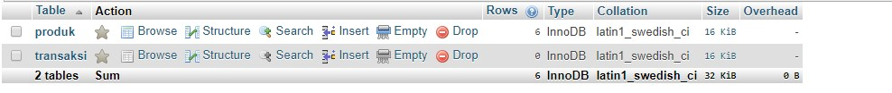

Source code Index.php

|  |
| --- |
| <?php  include 'fungsi.php';  ?>  <!DOCTYPE html>  <html lang="en">  <head>  <meta charset="utf-8">  <meta http-equiv="X-UA-Compatible" content="IE=edge">  <meta name="viewport" content="width=device-width, initial-scale=1">  <title>Warung</title>  <!-- Bootstrap -->  <link rel="stylesheet" href="https://maxcdn.bootstrapcdn.com/bootstrap/3.3.5/css/bootstrap.min.css">  <link rel="stylesheet" href="https://maxcdn.bootstrapcdn.com/font-awesome/4.4.0/css/font-awesome.min.css">    <style type="text/css">  .harga{  float: right;  margin-right: 500px;  }  .menuka{  float: left;  }  .menuki{  float: right;  margin-right: 450px;  }  .pesanka{  width: 170px;  float: right;  margin-right: 80px;  }  .pesanki{  width: 170px;  float: left;  }  </style>  </head>  <body>  <nav class="navbar-inverse" role="navigation" >  <div class="container-fluid">  <div class="navbar-header">  <a class="navbar-brand" href="#" data-toggle="modal" data-target="#buy"> </a>  </div>    </div><!-- /.container-fluid -->  </nav>  <div class="container" style="margin-top:50px;">  <div class=" panel-success">  <div class="panel-body bg-primary">  <div class="container">  <h1 height="50px" width="50px"> Warung Tegal</h1>  </div>  </div>  </div>  <div class="panel panel-default">  <div class="panel-body">  <div class="container">  <div class="col-md-10" style="width: 800px;">  <h2 style="float: left;">Harga Makanan:</h2>  <h2 style="float: right;">Harga Minuman:</h2>  </div>  <br><br><br> <h3></h3><br>  <h3 class="menuka">Bakso</h3><h3 class="menuki" > Es Jeruk </h3>  <br><br><br>  <h4 class="harga">3000</h4><h4>10000</h4>  <h3 class="menuka">Bakso Beranak</h3><h3 class="menuki" >Es Oyen </h3>  <br><br><br>  <h4 class="harga">4000</h4><h4>20000</h4>  <h3 class="menuka">Bakso Urat</h3><h3 class="menuki"style="margin-right: 470px">Es Teh </h3>  <br><br><br>  <h4 class="harga">2000</h4><h4>15000</h4>  </div>  </div>  </div>  </div>  <!-- [Modal Form] -->  <div class=" " id="" >  <div class="modal-dialog">  <div class="modal-content">  <div class="modal-header bg-danger" style="border-radius: 5px 5px 0px 0px;">  <h4 class="modal-title" id="">Form pembelian</h4>  </div>  <div class="modal-body">  <form class="form-group" action="fungsi.php" method="post">    <div class="input-group pesanki" >  <span class="input-group-addon" style="width: 100px;">Makanan</span>  <span class="form-control">Jumlah</span>  </div>  <div class="input-group pesanka" >  <span class="input-group-addon" style="width: 100px;">Minuman</span>  <span class="form-control">Jumlah</span>  </div>  <br><br><br>  <div class="input-group pesanki" >  <span class="input-group-addon" style="width: 120px">Bakso</span>  <input type="number" class="form-control" name="rawon">  </div>  <div class="input-group pesanka" >  <span class="input-group-addon" style="width: 120px">Es Jeruk</span>  <input type="number" class="form-control" name="teh">  </div>  <br><br><br>  <div class="input-group pesanki" >  <span class="input-group-addon" style="width: 120px">Bakso Beranak</span>  <input type="number" class="form-control" name="soto">  </div>  <div class="input-group pesanka" >  <span class="input-group-addon" style="width: 120px">Es Oyen </span>  <input type="number" class="form-control" name="jeruk">  </div>  <br><br><br>  <div class="input-group pesanki" >  <span class="input-group-addon" style="width: 120px">Bakso Urat</span>  <input type="number" class="form-control" name="kare">  </div>  <div class="input-group pesanka" >  <span class="input-group-addon" style="width: 120px">Es Teh</span>  <input type="number" class="form-control" name="marimas">  </div>  <br><br><br>  </div>  <div class="modal-footer">  <button type="submit" class="btn btn-primary" name="check" ><i class="fa fa-check"></i> Cek Total</button>  </form>  </div>  </div>  </div>  </div>  <!-- jQuery (necessary for Bootstrap's JavaScript plugins) -->  <script src="https://ajax.googleapis.com/ajax/libs/jquery/1.11.3/jquery.min.js"></script>  Include all compiled plugins (below), or include individual files as needed  <script src="https://maxcdn.bootstrapcdn.com/bootstrap/3.3.5/js/bootstrap.min.js"></script>  </body>  </html> |

Source code Fungsi.php

|  |
| --- |
| <style type="text/css">    .page {  width: 297mm;  min-height: 148mm;  padding: 2mm;  margin: 10mm auto;  border-radius: 5px;  background: white;  box-shadow: 0 0 5px rgba(0, 0, 0, 0.1);  }  .subpage {  padding: 0.5cm;  height: 80mm;  background-color: white;  opacity: 0.8;  filter: alpha(opacity=40);  }    @page {  size: a5;  size: landscape;  margin: 50;    }  @media print {  html {  width: 297mm;  height: 148mm;  }  body{  padding-top: 90px;  background: url("images/logoupprint.png") no-repeat;  background-size: 100%;  width: 297mm;  height: 148mm;  }  .page {  margin: 0;  border: initial;  border-radius: initial;  width: initial;  min-height: initial;  box-shadow: initial;  background: initial;  page-break-after: always;  }  }  </style>  <?php  include 'class.php';  $produk = new Produk();  $detail = new Detail();  $jumlah = new Transaksi($detail,$produk);  if (isset($_POST['check'])) {  $jmlRawon = $_POST['rawon'];  $jmlSoto = $_POST['soto'];  $jmlKare = $_POST['kare'];  $jmlTeh = $_POST['teh'];  $jmlJeruk = $_POST['jeruk'];  $jmlMarimas = $_POST['marimas'];  if ($jmlRawon == null && $jmlSoto != null && $jmlKare != null) {  $jumlah->getDetail()->setJumlahMakan(0,$jmlSoto,$jmlKare);  } elseif ($jmlRawon != null && $jmlSoto == null && $jmlKare != null) {  $jumlah->getDetail()->setJumlahMakan($jmlRawon,0,$jmlKare);  } elseif ($jmlRawon != null && $jmlSoto != null && $jmlKare == null) {  $jumlah->getDetail()->setJumlahMakan($jmlRawon,$jmlSoto,0);  } elseif ($jmlRawon == null && $jmlSoto == null && $jmlKare != null) {  $jumlah->getDetail()->setJumlahMakan(0,0,$jmlKare);  } elseif ($jmlRawon == null && $jmlSoto != null && $jmlKare == null) {  $jumlah->getDetail()->setJumlahMakan(0,$jmlSoto,0);  } elseif ($jmlRawon != null && $jmlSoto == null && $jmlKare == null) {  $jumlah->getDetail()->setJumlahMakan($jmlRawon,0,0);  } elseif ($jmlRawon == null && $jmlKare == null && $jmlSoto == null) {  $jumlah->getDetail()->setJumlahMakan(0,0,0);  } else {  $jumlah->getDetail()->setJumlahMakan($jmlRawon,$jmlSoto,$jmlKare);  }  if ($jmlTeh == null && $jmlJeruk != null && $jmlMarimas != null) {  $jumlah->getDetail()->setJumlahMinum(0,$jmlJeruk,$jmlMarimas);  } elseif ($jmlTeh != null && $jmlJeruk == null && $jmlMarimas != null) {  $jumlah->getDetail()->setJumlahMinum($jmlTeh,0,$jmlMarimas);  } elseif ($jmlTeh != null && $jmlJeruk != null && $jmlMarimas == null) {  $jumlah->getDetail()->setJumlahMinum($jmlTeh,$jmlJeruk,0);  } elseif ($jmlTeh == null && $jmlJeruk == null && $jmlMarimas != null) {  $jumlah->getDetail()->setJumlahMinum(0,0,$jmlMarimas);  } elseif ($jmlTeh == null && $jmlJeruk != null && $jmlMarimas == null) {  $jumlah->getDetail()->setJumlahMinum(0,$jmlJeruk,0);  } elseif ($jmlTeh != null && $jmlJeruk == null && $jmlMarimas == null) {  $jumlah->getDetail()->setJumlahMinum($jmlTeh,0,0);  } elseif ($jmlTeh == null && $jmlMarimas == null && $jmlJeruk == null) {  $jumlah->getDetail()->setJumlahMinum(0,0,0);  } else {  $jumlah->getDetail()->setJumlahMinum($jmlTeh,$jmlJeruk,$jmlMarimas);  }  $jumlah->getHargaMakan();  $jumlah->getHargaMinum();  $jumlah->setTotalSeluruh();  $jumlah->Finaltotal();  }  ?> |

Source code Class.php

|  |
| --- |
| <?php  include 'DB.php';  class Total  {  protected $totalHargaRawon;  protected $totalHargaSoto;  protected $totalHargaKare;  protected $totalHargaTeh;  protected $totalHargaJeruk;  protected $totalHargaMarimas;  protected $totalMakan;  protected $totalMinum;  protected $totalSeluruh;  protected $coba;  protected $detail;  protected $produk;  }  class Produk {  private $hargaRawon;  private $hargaSoto;  private $hargaKare;  private $hargaTeh;  private $hargaJeruk;  private $hargaMarimas;  function __construct() {  $db = new DB();    $users = $db->getRows('produk',array('order_by'=>'id_produk DESC'));  foreach ($users as $row) {  $harga[$row['nama']] = $row['harga'];  }  extract($harga);  $this->hargaRawon = $Rawon;  $this->hargaSoto = $Soto;  $this->hargaKare = $Kare;  $this->hargaTeh = $Teh;  $this->hargaJeruk = $Jeruk;  $this->hargaMarimas = $Marimas;  }  public function getHargaRawon()  {  return $this->hargaRawon;  }  public function getHargaSoto()  {  return $this->hargaSoto;  }  public function getHargaKare()  {  return $this->hargaKare;  }  public function getHargaTeh()  {  return $this->hargaTeh;  }  public function getHargaJeruk()  {  return $this->hargaJeruk;  }  public function getHargaMarimas()  {  return $this->hargaMarimas;  }  }  class Detail {  private $JmlRawon;  private $JmlSoto;  private $JmlKare;  private $JmlTeh;  private $JmlJeruk;  private $JmlMarimas;  public function setJumlahMakan($JmlRawon,$JmlSoto,$JmlKare){  $this->JmlRawon = $JmlRawon;  $this->JmlSoto = $JmlSoto;  $this->JmlKare = $JmlKare;  }  public function setJumlahMinum($JmlTeh,$JmlJeruk,$JmlMarimas){  $this->JmlTeh = $JmlTeh;  $this->JmlJeruk = $JmlJeruk;  $this->JmlMarimas = $JmlMarimas;  }  public function getJmlRawon()  {  return $this->JmlRawon;  }  public function getJmlSoto()  {  return $this->JmlSoto;  }  public function getJmlKare()  {  return $this->JmlKare;  }  public function getJmlTeh()  {  return $this->JmlTeh;  }  public function getJmlJeruk()  {  return $this->JmlJeruk;  }  public function getJmlMarimas()  {  return $this->JmlMarimas;  }  }  class Transaksi extends Total {  function __construct($detail,$produk)  {  $this->detail = $detail;  $this->produk = $produk;  }  public function getHargaMakan() {  $this->totalHargaRawon = $this->produk->getHargaRawon() * $this->detail->getJmlRawon();  $this->totalHargaSoto = $this->produk->getHargaSoto()* $this->detail->getJmlSoto();  $this->totalHargaKare = $this->produk->getHargaKare()* $this->detail->getJmlKare();  $this->totalMakan = $this->totalHargaRawon + $this->totalHargaSoto + $this->totalHargaKare;  }  public function getHargaMinum() {  $this->totalHargaTeh = $this->produk->getHargaTeh() * $this->detail->getJmlTeh();  $this->totalHargaJeruk = $this->produk->getHargaJeruk()* $this->detail->getJmlJeruk();  $this->totalHargaMarimas = $this->produk->getHargaMarimas()* $this->detail->getJmlMarimas();  $this->totalMinum = $this->totalHargaTeh + $this->totalHargaJeruk + $this->totalHargaMarimas;  }    public function getDetail() {  return $this->detail;  }  public function setTotalSeluruh() {  $this->totalSeluruh = $this->totalMakan + $this->totalMinum;  }  public function Finaltotal() {  echo "=================&& Struk Total Pembelian $$=================";  echo "<br>";  echo "Total Harga Makanan = Rp. ".$this->totalMakan.",-";  echo "<br>";  echo "<br>";  echo "Total Harga Minuman = Rp. ".$this->totalMinum.",-";  echo "<br><br>";  echo "Total Keseluruhan = Rp. ".$this->totalSeluruh.",-";  echo "<br>";  echo "========================================================";  echo "<br>";  echo $this->JmlMarimas;  echo $this->JmlKare;  echo "<script>window.print()</script>";  }  }  ?> |

Source code DB.php

|  |
| --- |
| <?php  class config  {  protected $dbHost = "localhost";  protected $dbUsername = "root";  protected $dbPassword = "";  protected $dbName = "pemvis";  }  class DB extends config{  public function __construct(){  if(!isset($this->db)){  // Connect to the database  try{  $conn = new PDO("mysql:host=".$this->dbHost.";dbname=".$this->dbName, $this->dbUsername, $this->dbPassword);  $conn -> setAttribute(PDO::ATTR_ERRMODE, PDO::ERRMODE_EXCEPTION);  $this->db = $conn;  }catch(PDOException $e){  die("Failed to connect with MySQL: " . $e->getMessage());  }  }  }    /*  * Returns rows from the database based on the conditions  * @param string name of the table  * @param array select, where, order_by, limit and return_type conditions  */  public function getRows($table,$conditions = array()){  $sql = 'SELECT ';  $sql .= array_key_exists("select",$conditions)?$conditions['select']:'*';  $sql .= ' FROM '.$table;  if(array_key_exists("where",$conditions)){  $sql .= ' WHERE ';  $i = 0;  foreach($conditions['where'] as $key => $value){  $pre = ($i > 0)?' AND ':'';  $sql .= $pre.$key." = '".$value."'";  $i++;  }  }    if(array_key_exists("order_by",$conditions)){  $sql .= ' ORDER BY '.$conditions['order_by'];  }    if(array_key_exists("start",$conditions) && array_key_exists("limit",$conditions)){  $sql .= ' LIMIT '.$conditions['start'].','.$conditions['limit'];  }elseif(!array_key_exists("start",$conditions) && array_key_exists("limit",$conditions)){  $sql .= ' LIMIT '.$conditions['limit'];  }    $query = $this->db->prepare($sql);  $query->execute();    if(array_key_exists("return_type",$conditions) && $conditions['return_type'] != 'all'){  switch($conditions['return_type']){  case 'count':  $data = $query->rowCount();  break;  case 'single':  $data = $query->fetch(PDO::FETCH_ASSOC);  break;  default:  $data = '';  }  }else{  if($query->rowCount() > 0){  $data = $query->fetchAll();  }  }  return !empty($data)?$data:false;  }    /*  * Insert data into the database  * @param string name of the table  * @param array the data for inserting into the table  */  public function insert($table,$data){  if(!empty($data) && is_array($data)){  $columns = '';  $values = '';  $i = 0;    $columnString = implode(',', array_keys($data));  $valueString = ":".implode(',:', array_keys($data));  $sql = "INSERT INTO ".$table." (".$columnString.") VALUES (".$valueString.")";  $query = $this->db->prepare($sql);  foreach($data as $key=>$val){  $query->bindValue(':'.$key, $val);  }  $insert = $query->execute();  return $insert?$this->db->lastInsertId():false;  }else{  return false;  }  }    /*  * Update data into the database  * @param string name of the table  * @param array the data for updating into the table  * @param array where condition on updating data  */  public function update($table,$data,$conditions){  if(!empty($data) && is_array($data)){  $colvalSet = '';  $whereSql = '';  $i = 0;  if(!array_key_exists('modified',$data)){  $data['modified'] = date("Y-m-d H:i:s");  }  foreach($data as $key=>$val){  $pre = ($i > 0)?', ':'';  $colvalSet .= $pre.$key."='".$val."'";  $i++;  }  if(!empty($conditions)&& is_array($conditions)){  $whereSql .= ' WHERE ';  $i = 0;  foreach($conditions as $key => $value){  $pre = ($i > 0)?' AND ':'';  $whereSql .= $pre.$key." = '".$value."'";  $i++;  }  }  $sql = "UPDATE ".$table." SET ".$colvalSet.$whereSql;  $query = $this->db->prepare($sql);  $update = $query->execute();  return $update?$query->rowCount():false;  }else{  return false;  }  }    /*  * Delete data from the database  * @param string name of the table  * @param array where condition on deleting data  */  public function delete($table,$conditions){  $whereSql = '';  if(!empty($conditions)&& is_array($conditions)){  $whereSql .= ' WHERE ';  $i = 0;  foreach($conditions as $key => $value){  $pre = ($i > 0)?' AND ':'';  $whereSql .= $pre.$key." = '".$value."'";  $i++;  }  }  $sql = "DELETE FROM ".$table.$whereSql;  $delete = $this->db->exec($sql);  return $delete?$delete:false;  }  } |